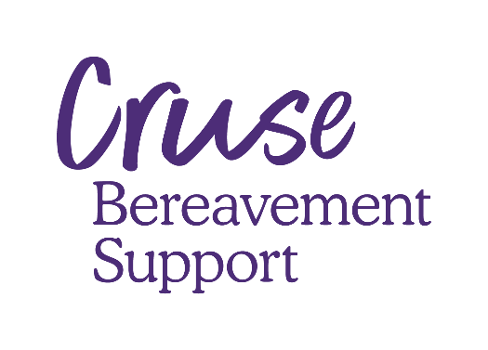

**Children, young people and grief**

**Large print version**

Children, young people and grief

There is no ‘right way’ to grieve and every child will respond differently. How they react will be affected by a lot of different things − their age, their understanding of death, and how close they were to the person who has died.

Like adults, children may feel hopeless and despairing when someone they love dies. They may feel angry that the person has left them. They may question why it has happened and blame themselves. They may also express their feelings of loss and pain in different and surprising ways. It may sometimes seem as if they do not care.

Children cannot sustain emotional pain in the way that adults can. They tend to move in and out of grief. They may appear to be coping much better than we expect.

It is important to remember that children may not have the words to express their feelings, and may show how they feel through their behaviour.

How children might react when someone dies

**Mood swings.** Happy one minute, and very angry or distressed the next.

**Unable to concentrate.** They may find it difficult to work on schoolwork or other activities.

**Quiet and withdrawn.** Some children find it difficult to share and express their thoughts and feelings, and may prefer to be alone.

**Disturbed sleep patterns.** Some children may find it difficult to settle to sleep for a while. They may wake in the night and have bad dreams.

**Behaving like a younger child.** Many children start doing things they did when they were younger, like sucking their thumb, wetting, or clinging to you.

**Difficulties with friends.** The death may make a child feel different from their friends and less confident with other people. They may be bullied, or even bully others.

**Breaking rules, stealing, skipping school.** A child may feel there is no point in behaving well.

Helping a bereaved child

* Try to stick to your usual day and night-time routines. Regular mealtimes, school work, breaks, playtime and bedtime can help keep younger children happy and healthy.
* We usually advise that children should attend a funeral or memorial if it is appropriate and they wish to. Make sure they understand what is going to happen and why. If they cannot attend or don’t want to, help them find other ways to mark the occasion.
* Allow the bereaved child or young person to say how they feel. Don’t be offended if they are angry with you or do not want to talk.
* Keep reminding them it’s OK to talk to you – remember they may not feel ready until many months have passed. They may need to come back to their grief as they grow older.
* Reassure them they are still loved.
* It’s fine to show them that you are sad too.
* Listen to them. Don’t dismiss how they feel or ignore any illness or pain they report.
* If behaviour is a problem it’s OK to treat this as you usually would – they may feel safer if rules and boundaries have not changed.
* If you are worried about a child ask for help. You could talk to their school, your GP or organisations such as Cruse. Don’t feel that you’ve failed if this happens. You are doing the right thing.

Teenagers and young people

Young people and teenagers are aware of the emotional impact, and long term implications, of losing someone close. But due to the developmental changes they are going through, their reactions to death are often very intense.

It’s important to remember that teenagers are not grown-ups. They might look like they’re grieving like adults but they need to be treated as a young person.

Teenagers might experience the following.

* Have difficulty managing strong emotions, becoming angry. They might end up in physical fights.
* Get upset and feeling the death was unjust. They might ask why the person who has died had to die, and talk about wider ideas about fate and mortality.
* Revert back to childish behaviour to feel more safe.
* Get involved with risky behaviours to distract from grief.
* Become concerned about who will pay the bills or care for them, especially if the person who died was their primary caregiver.
* Try to assume the role of an adult.
* Bottle up their emotions.
* Seek support outside their immediate family.

How to help teenagers cope with death

* Make sure they’re not given too much to do, especially things a responsible adult could do instead.
* Let them know it’s OK if they prefer to speak with friends, or people outside of the immediate family about the death.
* Gently encourage them to open up, express their emotions and share how they’re feeling.
* Reassure them that they are loved and supported.
* If they’re self-medicating or self-harming, get in touch with a medical professional.

For more support call our helpline

0808 808 1677